**Chapter 4**

**Image Restoration**

1. **Noise Removal**

Give the explanation, what is Median Filter for Noise Removal? How does it work? Applying the median filter to the following images.

|  |  |
| --- | --- |
| Noise 01 | Noise 02 |

1. **Deblur image**

Give the explanation, what is Wiener Filter for deblur image? How does it work? Applying the Wiener Filter to the following images.

|  |  |
| --- | --- |
| Blur 01 | Blur 02 |
|  |  |

Answer

Median Filter is s a nonlinear digital filtering technique, often used to remove noise. Such noise reduction is a typical pre-processing step to improve the results of later processing (for example, edge detection on an image). Median filtering is very widely used in digital image processing because, under certain conditions, it preserves edges while removing noise

How it works?  
For every pixel, a 3x3 neighborhood with the pixel as center is considered. In **median filtering**, the value of the pixel is replaced by the median of the pixel values in the 3x3 neighborhood.

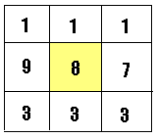

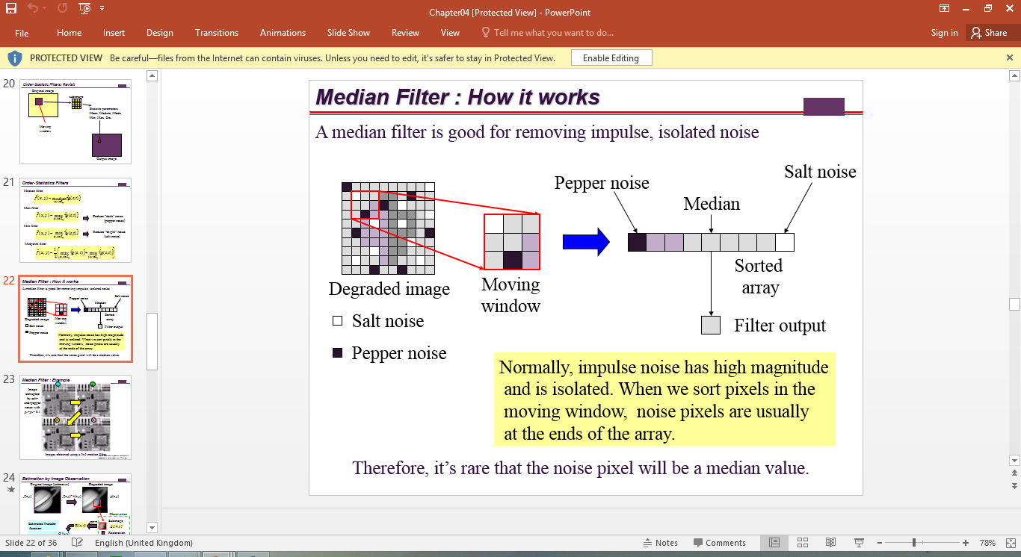

|  |  |
| --- | --- |
| Noise 01 | Noise 02 |
| J = imnoise(G,'salt',0.5);  m1 = medfilt2(m);  m = medfilt2(J);  m1 = medfilt2(m);  m2 = medfilt2(m1);  m3 = medfilt2(m2);  m4 = medfilt2(m3);  imshow(m4); | J = imnoise(G,'salt',0.005); of grayscale image |

1. **Deblur image**

Give the explanation, what is Wiener Filter for deblur image? How does it work? Applying the Wiener Filter to the following images.

**Wiener filter** is a filter used to produce an estimate of a desired or target random process by linear time-invariant (LTI) filtering of an observed noisy process, assuming known stationary signal and noise spectra, and additive noise. The Wiener filter minimizes the mean square error between the estimated random process and the desired process.

**How it work?**

The Wiener filter problem has solutions for three possible cases: one where a noncausal filter is acceptable (requiring an infinite amount of both past and future data), the case where a [causal](https://en.wikipedia.org/wiki/Causal_system) filter is desired (using an infinite amount of past data), and the [finite impulse response](https://en.wikipedia.org/wiki/Finite_impulse_response) (FIR) case where a finite amount of past data is used. The first case is simple to solve but is not suited for real-time applications. Wiener's main accomplishment was solving the case where the causality requirement is in effect, and in an appendix of Wiener's book [Levinson](https://en.wikipedia.org/wiki/Norman_Levinson) gave the FIR solution.

|  |  |
| --- | --- |
| Blur 01 | Blur 02 |
|  | LEN = 21;  THETA = 11;  PSF = fspecial('motion', LEN, THETA);  blurred = imfilter(G, PSF, 'conv', ‘circular');  imshow(blurred);  title('Blurred Image');  imshow(blurred); |